**اليوم الأول: السبت 30 شوال 1444 20 مايو 2023**

**Principles of Phono Surgery**

Time: 10:00 – 12:00

Language: English

Scientific paper

**Dr. Ibrahim Jamal Issa**

Otolaryngology Consultant

Laryngologist & Phono surgeon (MD)

Dr. Ibrahim Issa does not have any relevant financial and non-financial information to disclose.

**Principles of Phono Surgery**

* What phono surgery means
* How voice is produced
* What changes the voice?
* What normal voice means
* Types of vocal cord lesions
* Voice problems surgical treatment
* Vocal cord injections
* Treatment of vocal cord paralysis

**Able toing Outcomes:**

Attendees will be able to:

* Explain what phono surgery means.
* Explain how voice is produced.
* Discuss what changes the voice.
* Explain what normal voice means.
* List types of vocal cord lesions
* Explain vocal cord injections
* Discuss treatment of vocal cord paralysis

**اليوم الأول: السبت 30 شوال 1444 20 مايو 2023**

**علاج الخوف من الإجراءات الطبية عند الأطفال ذوي الاضطرابات النمائية**

الساعة: 10:00-12:00 صباحاً

اللغة: العربيه

دورة تدريبية

***الأستاذ/أحمد عيد***

*استشاري النطق والتخاطب ومحلل سلوكي معتمد*

Mr. Ahmed Eid does not have any relevant financial and non-financial information to disclose.

يعاني الأطفال ذوي الاضطرابات النمائية وخاصة التوحد من خو ف شديد من الإجراءات الطبية مثل سحب عينات الدم و أخذ الحقن وزيارة طبيب الاسنان وغيره من الإجراءات الطبية. هذا الخوف يكون مبالغا به بشكل كبير مما يؤدي الى ظهور مشاكل سلوكية كبيرة ينتج عنها عدم او ضعف الخدمة الطبية المقدمة. تناقش هذه الورشة السلوكيات المصاحبة وكيفية تصميم خطة علاجية مناسبة

**نتائج التعلم:**

**سيتعلم الحضور**

* الأساس السلوكي للخوف من الإجراءات الطبية
* الأساس العلمي لإدارة سلوك الخوف
* شرح إجراءات التدخلات السلوكية

**الفئات المستهدفة:**

* أسر الأطفال ذوي الاضطرابات النمائية والتوحد
* الاخصائيون

**اليوم الأول: السبت 30 شوال 1444 20 مايو 2023**

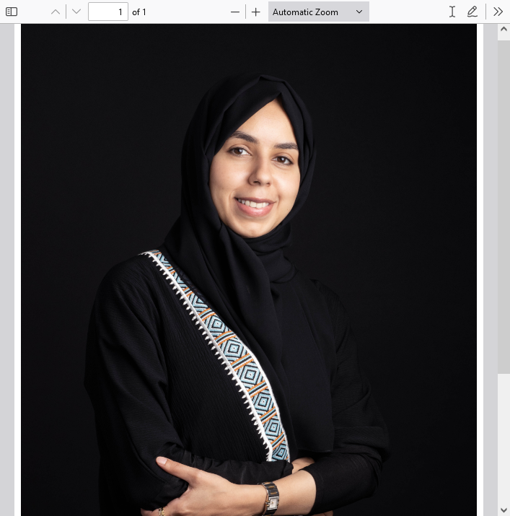**Play-based AVT Strategies**

**تطبيق استراتيجيات التأهيل السمعي اللفظي AVT خلال اللعب**

الساعة 10:00-11:30 صباحاً

اللغة: العربيه

دورة تدريبية

***الأستاذة/دعاء عبد الله شحاته***

*أخصائية النطق واللغة، حاصلة على شهادة الكفاءة الاكلينيكية من الجمعية الأمريكية للنطق والسمع ASHA*

Ms. Duaa Shehata does not have any relevant financial and non-financial information to disclose.

**الأهداف والمخرجات: سيتعلم الحضور:**

* نبذة عن منهج التأهيل السمعي اللفظي
* معرفة استراتيجيات التأهيل السمعي الكلامي الأساسية
* أهمية اللعب في تأهيل ضعاف السمع وتحفيز لغتهم
* اختيار فكرة النشاط/ اللعب بناءً على أهداف التأهيل العلاجية
* تطبيق الاستراتيجيات خلال أنشطة اللعب
* دمج الاستراتيجيات مع أهداف الجلسة العلاجية بحسب عمر الطفل الزمني/السمعي- اللغوي
* تدريب الوالدين

**اليوم الأول: السبت 30 شوال 1444 20 مايو 2023**

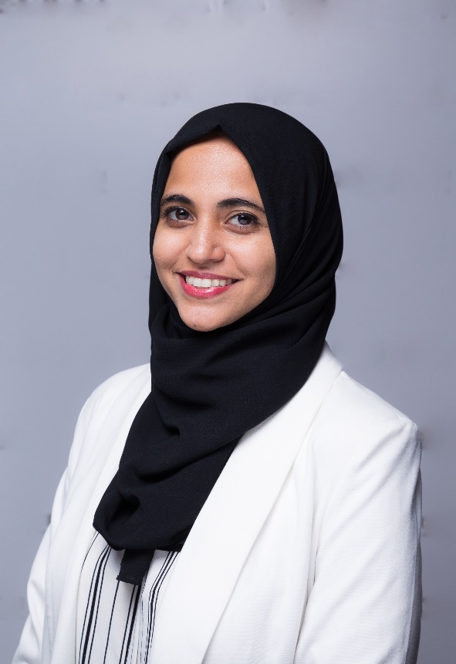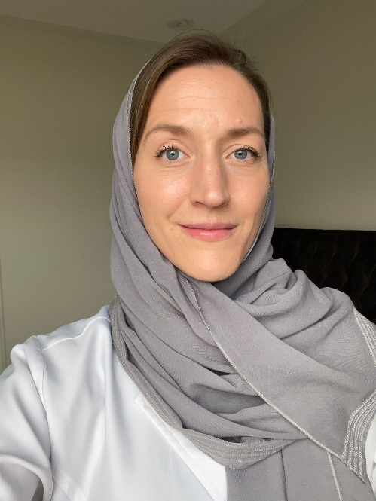**Assessment to Practice: A Client-Centered Approach to ABA Interventions**

Time: 10:00 – 12:00

Language: English

Short course

***Shumaila Jaffrey,*** *BCBA, LABA Independent supervisor*

***Katelyn Craig,*** *BCBA Service agreement BCBA Center for Autism Research, KFSH Research Center*

Ms. Shumaila Jaffrey does not have any relevant financial and non-financial information to disclose.

Ms. Katelyn Craig does not have any relevant financial and non-financial information to disclose.

**Intended audience:** Parents, RBTs, newly certified BCBAs and those working with individuals with autism/ASD.

**Abstract:** As the field of ABA is progressing quickly within Saudi Arabia and the Middle East, there are many more families specifically requesting for ABA services. There has also been an increase in the number of service providers at different levels of certification, including those who have recently obtained certification.

With this, families may not understand the importance or process of assessment and goal selection, or that their priorities and preferences play an important role in contributing to their child’s treatment. Similarly, professionals often need additional support in developing the right treatment plan that is catered individually to each client’s needs, skills, and environment, especially due to the diversity in ASD populations. This presentation has two primary purposes: First, it aims to introduce both parents and professionals to the process of skills & behavioural assessment using a variety of tools, possibly combining these to create more effective treatment plans. For parents, this is valuable so when they are reaching out for ABA services, they can emphasise on assessment and are aware of their options and what is best suited for their child. Second, and more importantly, this presentation aims to help select appropriate teaching goals according to assessment results. This includes language, social, academic, and independent living skills, identifying deficits and behaviour concerns. For parents already receiving ABA services, this would help understand why certain goals are prioritised and what to request from service providers during intervention. For professionals, this will also assist in analysing delays in able toing due to goal selection.

**Able toing Outcomes:**

Attendees will able to to:

* Identify the difference between commonly used indirect & direct assessment tools (ABLLS/AFLS, VB-MAPP, EFL, PEAK)
* Understand how to select an appropriate assessment based on client needs.
* Basics of interpreting assessment results
* Using assessment results to select appropriate, client-centred goals.
* Troubleshooting through basic concerns on client progress

**اليوم الأول: السبت 30 شوال 1444 20 مايو 2023**

**تدريب أولياء أمور الأطفال من ذوي اضطراب التواصل على استراتيجية التواصل بتبادل الصور باستخدام سماعة أذن ومرآة أحادية الاتجاه**

الساعة 10:00-11:30 صباحاً

اللغة: العربيه

محاضرة

***د. بتول السيد حسان***

*PhD in Special Education, BCBA-D* ***.****دكتوراه في التعليم الخاص*

Dr. Batool Hassan does not have any relevant financial and non-financial information to disclose.

**ملخص:**

تتواجد مجموعة متنوعة من التدخلات لدعم مهارات التواصل الاجتماعي للأطفال الذين يعانون من اضطراب  
الاتصال لتعزيز مهارة التواصل في البيئة المنزليةوالمدرسة وفي المجتمع.حيث تشمل هذه التدخلات تعليمات تجريبية منفصلة (Lovaas،1978) ، والسلوكيات اللفظية التي تشمل المصاداة والتسمية والاستجابة (Sundberg&Michael ،2001، )والتدريب المحوري على الاستجابة (McFadden et al.،2914) ، ونمذجة الفيديو والنمذجة الذاتية (Wret&Neisworth،2003) ، وتدخلات الاتصال المعزز والبديل (AAC) (Beukelman&Mirenda،2005). يتكون نظام التواصل البديل والذي يسمى بAACمن تدخلات بدون مساعدة لا تتطلب أي معدات خارجية إلى جانب أجزاء من الجسم (مثل لغة الإشارة والإيماءات والعلامات اليدوية) والتدخلات المساعدة التي تتطلب مساعدات خارجية مثل الأساليب القائمة على الصور والأجهزة الإلكترونية (Beukelman&Mirenda،2005.) تدخلAACالشائع هو نظام اتصالات تبادل الصور (PECS) (Bondy A،Frost،2001). استخدم الباحثون PECSلتعليم مهارات الاتصال التي تضمنت الطلب واضافة ملاحظات عن طريق تبادل بطاقات الصور (Bondy A، Frost ،2001). يقدر مدى فعالية العلاج PECSمن50-90٪ اعتمادًا على نوع المهارات المطلوبة (Hart&Banda،2009 ). ومع ذلك،تظهر أبحاث PECSأن غالبية الدراسات أجريت من قبل المعالجين أو الباحثين وليس الآباء.

**الغرض:**  
تدريب أولياء الأمور باستخدام وسيلة التدريب للمهارات السلوكية والمسمى ب(Behavior Skills Training) لاستخدام  
نظام التواصل لتبادل الصور PECS مع أطفالهم الذين يعانون من اضطراب التواصل لتطوير مهارات الاتصال.  
الاستراتيجية: تدريب أولياء الأمور من خلال تطبيق تدخلBST التي تتضمن تعليمات مكتوبة ونمذجة ومشاهدة مقاطع فيديو وممارسة وملاحظات. تعد الملاحظات اللفظية جزءًا أساسيًا من هذا البرنامج التدريبي، والذي يتضمن تصحيح الخطأ والتعزيز والإجابة على الأسئلة قبل أو أثناء أو بعد جلسات التدخل الواقعية مع أطفالهم. يتم أيضا توفير سماعة أذن لتقديم ملاحظات فورية أثناء تنفيذ استراتيجية التبادل بالصور. سماعة الأذن يكون جهاز اتصال صغير، لاسلكي، وسهل الاستخدام. يمكن أن يساعد هذا الجهاز في توفير اتصال صوتي أحادي الاتجاه أو ثنائي الاتجاه بين الأخصائي والأسرة أثناء التدريب. من المرجح أن تساعد الملاحظات الفورية المتدرب على اكتساب المهارات بشكل أسرع واستخدامها بشكل متكرر أكثر من التعليقات المتأخرة.بالإضافة إلى ذلك، فإن مشاركة الوالدين في تنفيذ التدخلات معروفة على نطاق واسع بأنها عامل فعال لنمو الطفل وتعتبر أفضل ممارسة للأطفال الصغار الذين يعانون من اضطراب التواصل. حيث تشير النتائج إلى أنه عندما يتلقى الآباء التدريب المناسب وردود الفعل المناسبة، يمكنهم تدريب أطفالهم على استخدام PECS لتعزيز مهارة الطلب بشكل مستقل.

**اليوم الأول: السبت 30 شوال 1444 20 مايو 2023**

**Behavioral Issues in Hearing Impaired and Cochlear Implanted Children.**

Time: 10:00 – 11:00

Language: English

Panel

***Prof. Khaled Al Nouri,*** *MD, FRCSC, American Board of Otolaryngology, Head and Neck Surgery*

***Dr. Shaza Saleh,*** *PhD in Audiology, Consultant Audiologist and Head of Audiology, KAESC, KSU Medical City, Riyadh*

***Dr. Nahla Dashash****, PhD,CCC-SLP, ASHA Fellow, Clinical Services Director, JISH, Jeddah*

***Mrs. Cherine Basfer****, M.Sc. in Psychology, BCBA, Program Director, Carbone Clinic, Dubai*

Prof. Khaled Al Nouri does not have any relevant financial and non-financial information to disclose.

Dr. Shaza Saleh does not have any relevant financial and non-financial information to disclose.

Ms. Cherine Basfar does not have any relevant financial relationship with JISH.

Ms. Cherine Basfar has non-financial relationship with JISH as she sometimes volunteers at JISH.

Dr. Nahla Dashash has a financial and a non-financial relationship with JISH as she is a JISH employee and therefore receives a salary from JISH.

**Abstract:**

This panel will be discussing general challenging behaviors faced by Parents, ENT’s surgeon’s Audiologists and SLP’s working with typically developing children CI and hearing impaired children with such as (taking off Has, expressing anger by throwing CI device and losing it in playground, airport, trash mouthing HA's battery, short attention span/ lack of concentration, not accepting Cn's, correction/ feedback, not keeping the hearing aids initially which will be followed by not keeping the CI processors, not showing clear responses to the family, not showing clear responses or cooperating during aided with HA/CI or for programming, behavioral issues causing them to pretend discomfort, habitual removal of CI processor with loud sounds even without discomfort after having a too loud map, habitual removal of CI processor to avoid listening to parents, deactivating the processor while wearing it or lowering the coil beneath the hair without the parents knowing, removing the processor or coil at school, refusing to get a new program). The panel will also discuss challenging behaviors faced by Parents ENT’s surgeon’s Audiologists, SLP’s and Psychologist/ABA specialists working with ASD CI and hearing-impaired children such as (mouthing HA's battery (sensory), throwing reinforcement, not sitting on the chair, hyperactivity, crying to avoid training, exhibiting different types of behaviors because of sensitivity to sounds)

**Able toing Outcomes:**

Attendees will able to to:

* List challenging behaviors exhibited by Young typically developing HI / CI children faced by (Audiologists and ENTs) during audiological and ENT assessment and follow up protocols
* List challenging behaviors exhibited by Young typically developing HI / CI children faced by SLPs during assessment and intervention sessions
* List challenging behaviors exhibited by Young ASD HI /CI children faced by (Audiologists and ENTs) during audiological and ENT assessment and follow up protocols
* List challenging behaviors exhibited by Young ASD HI / CI children faced by SLPs and ABA therapists during assessment and intervention sessions
* Outline some strategies that will help in preventing problem behaviors
* Explain tools and strategies which can be used to manage problem behaviors in ASD HI/ CI young children.
* Identifying some of the strategies to deal with Problems behaviors when they occur
* in typically developing HI/ CI young children.

**اليوم الأول: السبت 30 شوال 1444 20 مايو**

**2023**

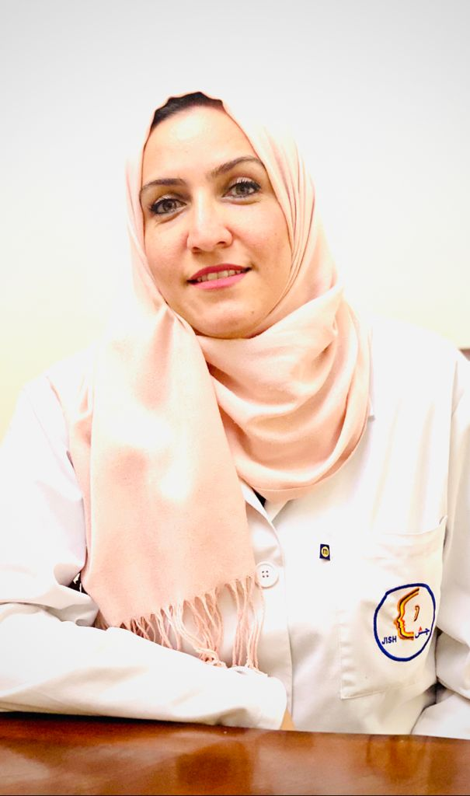**The Role of SLP in Voice Therapy**

Time: 10:20 – 11:05

Language: English

Scientific paper

***Mrs. Manar Adwan,*** *MA, SLP, JISH, Jeddah*

Mrs. Manar has a financial relationship with JISH as she is a JISH employee and therefore receives a salary from JISH. Mrs. Manar doesn’t have any relevant non-financial information to disclose.

**Abstract:**

We aim to discuss the types of voice problems, and different disorders that cause vocal cord problems. We will discuss the role of speech and language therapist in addressing these problems in addition to medical and surgical interventions that are offered by the phonetician.

**Able toing Outcomes:**

Attendees will able to to:

* List the types of voice problems.
* List different disorders that affect phonation.
* List therapy strategies for phonation disorders.
* Explain different techniques for voice therapy.

**اليوم الأول: السبت 30 شوال 1444 20 مايو 2023**

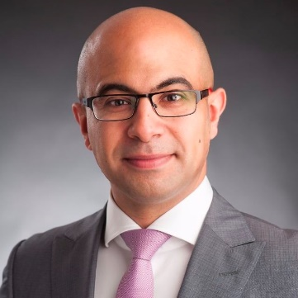

**Velo Pharyngeal Insufficiency VPI**

Time: 11:05-11:20

Language: English

Scientific paper

***Dr. Faisal Zawawi,*** *Otolaryngology Consultant Laryngologist, MD, MSc., KAUH, Jeddah*

Dr. Faisal Zawawi does not have any relevant financial and non-financial information to disclose.

**Able toing Outcomes:**

Attendees will able to to:

* List the steps of evaluating the child presenting velopharyngeal insufficiency symptoms.
* Differentiate between different causes of velopharyngeal insufficiency.
* Explain the different modalities of managing children with velopharyngeal insufficiency.

**اليوم الأول: السبت 30 شوال 1444 20 مايو 2023**

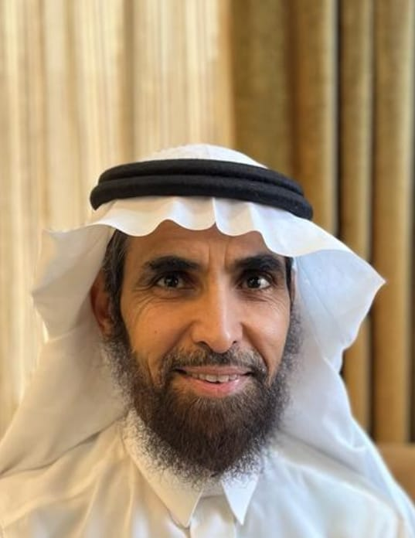

**Roadmap for an SLP Toward Becoming a Professional Clinician  
in Swallowing Disorders.**

Time: 11:20-11:40

Language: English

Scientific paper

***Dr. Abdulrahman Ibrahim Al-Akeel,*** *PhD, Consultant Pathologist in Swallowing and Communication Disorders*

Dr. Abdulrahman Al-Akeel does not have any relevant financial and non-financial information to disclose.

**Abstract:**

Providing assessment and therapy for functional swallowing disorders is within the scope of practice of speech-language pathologists (SLPs). An SLP needs to acquire knowledge and skills in swallowing disorders as he/she needs to be competent in both assessment and treatment of swallowing disorders. This includes competencies in clinical swallowing  
screening, Video fluoroscopy swallow study (VFSS), Fiberoptic Endoscopic Examination of Swallowing study (FEES), writing treatment plan and implementing it. In this presentation, the presenter will suggest resources for basic knowledge and skills that will enable an SLP to deal with adult clients suffering from functional swallowing disorders. This will include reading materials, courses, workshops, and hand on training.

**Able toing Outcomes:**

Attendees will able to to:

* Identify reading materials (textbooks, articles, etc...) that will enable them to know more about swallowing disorders.
* Identify courses (online and in person) that will provide them with knowledge and skills about swallowing disorders.
* Identify workshops (online and in person) that will provide them with knowledge and skills about swallowing disorders.
* Identify hands-on-training that will improve their skills in assessing and treating swallowing disorders.
* Identify training sites that provide training in VFSS.
* Identify training sites that provide training in FEES.
* Identify online courses that enable them to write treatment plan for swallowing disorders.

**اليوم الأول: السبت 30 شوال 1444 20 مايو 2023**

**CMV**

Time: 11:40-11:55

Language: English

Location: Lecture room 1

Scientific paper

***Dr. Faisal Zawawi,*** *Otolaryngology Consultant Laryngologist, MD, MSc., KAUH, Jeddah*

Dr. Faisal Zawawi does not have any relevant financial and non-financial information to disclose.

**Able toing Outcomes:**

Attendees will able to to:

* Explain the importance of screening for congenital CMV
* Explain how to evaluate a newborn with suspected congenital CMV
* Describe the pathway of congenital CMV screening in newborn hearing screening.

**اليوم الأول: السبت 30 شوال 1444 20 مايو 2023**

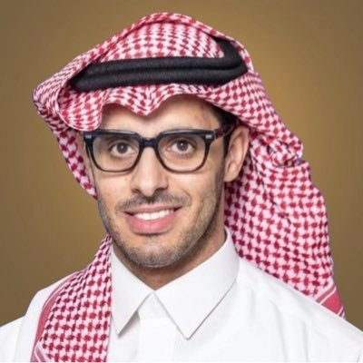

**Detecting and Treating Language Disorders in Early Childhood.**

Time: 11:55-12:25

Language: English

Scientific paper

***Fahad Alnemary,*** *Ph.D. in Special Education, Co-Founder and CEO of Ynmo*

Dr. Fahad Alnemary does not have any relevant financial and non-financial information to disclose.

**Abstract:**

This initiative, in partnership with Almuhaideb Social Foundation aims to detect and treat language disorders among children in early childhood (8-36 months) using the communicative development inventory (CDI) as a screening tool. Children who are identified at risk are eligible for our free, virtual early intervention program consisting of four sessions. This initiative includes additional activities, such as:

1. Awareness campaigns: We publish awareness materials such as videos, articles, infographics, and guidebooks for families to understand language development and language disorders.
2. Training program: 20-hour training program for nursery and daycare staff which aims to train them to identify children with language disorders and support them.
3. Research studies:

**We are conducting research studies on the following topics:**

1. Language delay in Saudi children: Prevalence and risk factors
2. Developing a short form of the Saudi CDI
3. Needs of families and service providers
4. The economic cost of language disorders

**Able toing Outcomes:**

Attendees will able to to:

* identify the importance of early language screening and current challenges in the practice in Saudi Arabia.
* describe the efficacy of virtual sessions for early intervention.
* As a result of this lecture, the participant will be able to apply the framework of Faseeh initiative to their practice.

**اليوم الأول: السبت 30 شوال 1444 20 مايو 2023**

**Challenges in Managing and Treating the Phobia from Medical Procedures in Children with Developmental Disabilities**

Time: 12:00 –1:00

Language: English

Panel

***Mr. Ahmad Eid, M.A., Consultant,*** *Speech Pathologist, Board Certified Behavior Analyst, BCBA., Clinical Supervisor.*

***Dr. Shahad Mohammed AlKhalifah,*** *Senior OT, Head of Occupational Therapy, Autism Center of Excellence*

***Dr. Reem Alarakia,*** *Dentist, KFAFH*

Mr. Ahmed Eid does not have any relevant financial and non-financial information to disclose.

Dr. Shahad Al-Khalifah does not have any relevant financial and non-financial information to disclose.

Dr. Reem Al-Arakia does not have any relevant financial and non-financial information to disclose.

**Abstract:**

Children with developmental disabilities have exaggerated fear from medical related procedures. This fear related behavior will affect the quality of medical care they receive. For this important reason, the issue of management these behaviors are of interest to behavior analysts who provide full scientific explanation and possible effective behavioral interventions as well.

**Able toing outcomes:**

Attendees will able to to:

* Describe the scientific explanation of fear related to clinical procedures from behavioral perspective.
* Explain how the phobia from the medical procedure could lead to the children's psychological trauma, demonstrated by anxiety, aggression, anger, and similar expressions of emotion.
* Describe how the lack of control of the child's environment could cause psychological trauma during the medical procedure.
* List the antecedent based interventions related to fear behaviors.
* Explain the possible consequence-based interventions.
* Describe any issues related to fear from medical procedures.
* Describe how the families know what to expect and what is expected of the children.
* Describe how to provide emotional support through recognizing and normalizing common fears and responses.

**اليوم الأول: السبت 30 شوال 1444 20 مايو 2023**

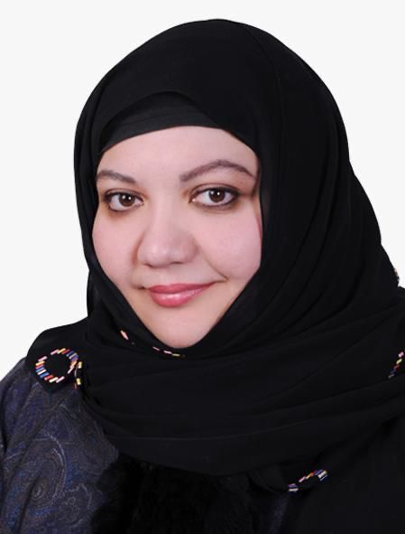**Binaural Hearing Evaluation and Cochlear Implant**

Time: 11:30-1:00

Language: English

Short course

***Dr. Shaza Saleh,*** *PhD in Audiology, Consultant Audiologist and Head of Audiology, KAESC, KSU Medical City, Riyadh*

Dr. Shaza Saleh does not have any relevant financial and non-financial information to disclose.

**Abstract:**

Binaural hearing, particularly the ability to detect small differences in the timing of sounds at the two ears (interaural time differences, ITDs) underpins the ability to localize sound sources, and is important for decoding complex spatial listening environments into separate objects. The relevance of binaural hearing to communication in every-day listening situations is increasingly recognized in therapeutic interventions; the UK’s National Institute for Health and Clinical Excellence (NICE), for example, recommends that all children born deaf receive bilateral cochlear implants. Despite its importance in everyday listening tasks, however, brain mechanisms responsible for spatial listening remain poorly understood (certainly compared with visual spatial processing), and the potential benefits of binaural hearing for users of hearing aids and cochlear implants slow to be realized. This instructional course will provide an understanding of how binaural hearing can be assessed and how it might be restored in users of hearing aids and cochlear implants.

**Able toing Outcomes:**

Attendees will able to to:

* Identify the underlying processes of binaural hearing.
* List and compare between the different binaural hearing evaluation tests.
* Setup, perform and interpret different binaural hearing tests with normal hearing individuals.
* Setup, perform and interpret different binaural hearing tests with hearing aids and cochlear implants.

**اليوم الأول: السبت 30 شوال 1444 20 مايو 2023**

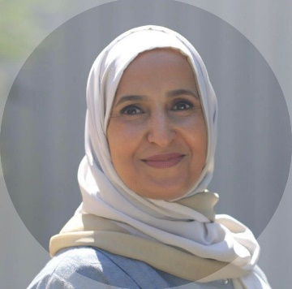**Multidisciplinary Approach in Evaluating Autism Spectrum**

Time: 12:00-1:00

Language: English

Lecture

***Amal Alyamani,*** *Clinical Psychology consultant, KFAFH, Jeddah*

Dr. Amal Alyamani does not have any relevant financial and non-financial information to disclose.

**Abstract:**

Providing a comprehensive diagnostic Evaluation for autism requires a process that involves different steps, professions, and tools. The current presentation is to outline what is required in providing such an evaluation.

**Able toing Outcomes:**

Attendees will able to to:

* + Describe the process of evaluation of autism spectrum.
  + Describe the assessment Tools used in evaluating autism spectrum.
  + Describe the specialties involved and their role in evaluating autism spectrum
  + Explain how to provide feedback and recommendations to clients with autism spectrum.

**السبت 30 شوال 1444 20 مايو 2023**

**Case Presentations:** **Effective Outcomes of Combined OT and SLP Intervention**

Time: 12:00-1:00

Language: English

Lecture

***Sarah Alghunaim –*** *OT and certified Sensory Integration Therapist, Tayf Aziz Center, Riyadh*

***Halah Abuliyah –*** *Msc.CCC-SLP, BCaBA, QBA, Head of SLP Clinic, Tayf Aziz Center, Riyadh*

Ms. Sara Alghunaim does not have any relevant financial and non-financial information to disclose.

Mrs. Hala Abuliyah does not have any relevant financial and non-financial information to disclose.

**Abstract:**

Members of the interdisciplinary team provide joint sessions from multiple disciplines to maximize the clients benefit of intervention. Joint sessions integrate the skills of both the clinicians and the children. The combination of the two therapeutic approaches allows therapists to address most of the core deficits and differences attributed to behavioral and developmental disabilities.

Speech Pathologists and Occupational Therapists are known to be very collaborative in their practice, with one often complimenting the other and vice versa.  Effective collaborative treatment between OTs and SLPs lies in integrating sensory approach into communication and evidence-based strategies that result in exceptional outcomes.

In this lecture, a case of a child with sensory processing and communication difficulties will be discussed, outlining the cohesive plan of intervention and the execution of treatment strategies in combined therapeutic activities.

**Able toing Outcomes:**

Attendees will able to to:

* Identify sensory approach endorsing communication skills.
* Describe how the vestibular system provokes the verbal outcome.
* Identify an environment to stimulate language and to encourage more chances for communication.
* Explain sensory stimulus as reinforcement to maintain communication outcome and formulate vocal sounds into understandable words.
* Explain the correlation between self-regulation, sensory processing difficulties and communication skills.

**السبت 30 شوال 1444 20 مايو 2023**

**The Journey of a Child with Cleft Palate**

Time: 2:00 –3:00

Location: Lecture room 1

Language: English

Panel

***Dr. Nisreen Al Awaji,*** *Head of Healthand Communication Sciences Department, PNU, Riyadh, & Senior SLP, KAAUH, Riyadh*

***Dr. Faisal Zawawi,*** *Otolaryngology Consultant Laryngologist, MD, MSc. KAUH*

***Dr. Hatem Alnuman,*** *Consultant, Plastic and Reconstructive / Pediatric Plastic Surgery, Assistant Professor, KSAU, Jeddah*

***Dr. Ali Habib,*** *Dental and maxillofacial orthodontic consultant, KAUH*

Dr. Nisreen Al Awaji does not have any relevant financial and non-financial information to disclose.

Dr. Faisal Zawawi does not have any relevant financial and non-financial information to disclose.

Dr. Hatem Alnuman does not have any relevant financial and non-financial information to disclose.

Dr. Ali Habib does not have any relevant financial and non-financial information to disclose.

**Able toing outcomes:**

Attendees will able to to:

* Describe the treatment pathway for cleft and when speech therapy starts.
* Describe the appropriate focus and intervention stages of SLPs for different developmental stages.
* Explain when speech therapy is not appropriate for correction of abnormal speech in cleft palate population.
* Explain the role of SLP within a multidisciplinary team.

**السبت 30 شوال 1444 20 مايو 2023**

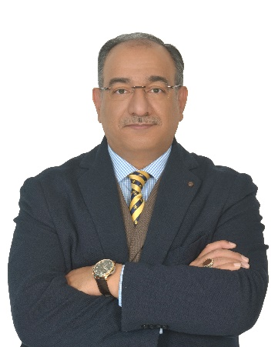

**Management of Childhood Apraxia of Speech**

Time: 3:00-6:00

Language: English

Workshop

***Dr. Wael A. Al-Dakroury,*** *Ph.D., CCC-SLP Co-Founder and Director of the Communication Disorders Department, Psych Care Complex, Adjunct Associate Professor at the College of Medicine, AlFaisal University, Riyadh*

Dr. Wael Al-Dakroury does not have any relevant financial and non-financial information to disclose.

**Abstract:**

Childhood apraxia of speech (CAS) is a complex motor speech disorder that may contribute to academic and social difficulties.  To effectively serve a child with CAS, a Speech-Language Pathologist (SLP) needs to consider and understand all the various components of the child’s speech system. The broad scope and depth of understanding of skills required to work with children with CAS present real challenges, that can be overwhelming, especially for SLPs who lack knowledge about CAS and/or experience working with children with motor speech disorders. This seminar is for novice and experienced SLPs seeking background information, characteristics, assessment, differential diagnostic protocols, and intervention approaches related to children with CAS.

**Able toing Outcomes:**

Attendees will able to to:

* Describe characteristics most associated with CAS and comorbidities.
* Identify guidelines for conducting a comprehensive assessment of CAS to support an accurate differential diagnosis.
* Describe treatment approaches that have been shown to lead to positive outcomes for children with CAS

**السبت 30 شوال 1444 20 مايو 2023**

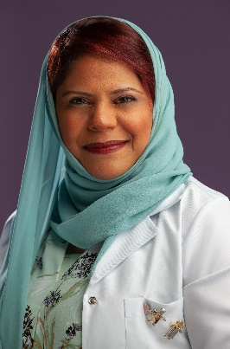

**The Power of Social Story**

Time: 2:00-3:00

Language: English

Lecture

***Dr. Amel Alawami,*** *Developmental behavioral pediatrician (DBP) at Johns Hopkins Aramco Healthcare center, Dhahran*

Dr. Amel Alawami does not have any relevant financial and non-financial information to disclose.

**Abstract:**

1. Explain a social story
2. Describe how to write a social story
3. Describe the use of social stories in training and teaching new skills

**Able toing Outcomes:**

Attendees will able to to:

* Define the social story.
* Describe the content of social story.
* Explain how to write a social story.
* Practice hands-on writing a social story

**السبت 30 شوال 1444 20 مايو 2023**

**Social Skills Panel**

Time: 3:00 –4:00

Location: Lecture room 2

Language: English

Panel

***Dr. Amel Alawami****, Developmental behavioral pediatrician (DBP) at Johns Hopkins Aramco Healthcare center, Dhahran*

***Mrs. Rozan Alkhateeb,*** *MA, CCC-SLP, Program Manager (BCBA) and Speech & Language Department at Stepping Stones Center, Al- Khobar.*

***Dr. Jihad Almasri,*** *Speech-Language Pathologist and Supervisor, Medical Director, Al Hanan Rehabilitation Center, Jeddah.*

Dr. Amel Alawami does not have any relevant financial and non-financial information to disclose

Mrs. Razan Alkhateeb does not have any relevant financial and non-financial information to disclose.

Dr. Jihad Almasri does not have any relevant financial and non-financial information to disclose.

**Able toing outcomes:**

* The panelists will discuss the importance of improving social skills for children with social communication challenges through the following strategies and intervention approaches:
* Teaching key social rules such as turn-taking, waiting, reciprocating comments, initiation and transitioning within a conversation.
* Behavior Skills Training using video modeling, role play and practicing.
* Practicing within structured and less structured contexts.
* Usage of Visual Prompts.
* Usage of social stories for teaching new skills.
* Improving the abstract concepts of language through different social experiences.
* Teaching conversational repair skills, rejection and negotiation.

**السبت 30 شوال 1444 20 مايو 2023**

**The Journey of a Child with Cochlear Implant**

Time: 4:00 –5:00

Location: Lecture room 2

Language: English

Panel

***Dr. Mohammed Numan Garada,*** *Audiological Medicine, KAU, Jeddah*

***Dr. Faisal Zawawi,*** *Otolaryngology Consultant Laryngologist, MD, MSc., KAUH, Jeddah*

***Ms. Duaa Abdullah Shehata,*** *Speech and Hearing Therapy, NGH, Jeddah*

Dr. Mohammed Garada does not have any relevant financial and non-financial information to disclose.

Dr. Faisal Zawawi does not have any relevant financial and non-financial information to disclose.

Ms. Duaa Shehata does not have any relevant financial and non-financial information to disclose.

**Able toing outcomes:**

Attendees will able to to:

* Identify candidates for Cochlear implantation for adults and children.
* Provide updates regarding the latest diagnostic options and procedures for hearing assessment.
* Describe the intraoperative measurement tests.
* Provide the possible procedures that can be followed or performed when programming a recipient’s cochlear implant after surgery.

**السبت 30 شوال 1444 20 مايو 2023**

**A Virtual Training Program for Families with Children with Autism (I Can Train My Child Program) The Autism Center of Excellence’s Experience**

Time: 2:00-6:00

Language: English

Workshop

***Mr. Saleh Suliman Alsuwailem,*** *Speech and Hearing Therapy, Director, Speech& Language pathology department, Autism Center of Excellence*

Mr. Saleh Alsuwailem does not have any relevant financial and non-financial information to disclose.

**Abstract:**

Parent-mediated intervention is an evidence-based practice that involves training the parent(s) on how to develop their children's communication and social skills, two core and essential areas to address in the treatment of a child with autism spectrum disorder. The Autism Center of Excellence has prepared an integrated program for training families virtually under the name of (I Can Train My Child) program, with the goal of developing the child's abilities in his natural environment, to include aspects of social interaction and communication skills, motor-sen sory skills, behavioral skills, and activities of daily living. The program (I Can Train My Child) consists of 12 training sessions that are virtually presented to parents using advanced technology, including the documentation of the child's behavior through visual recording, identifying strengths and weaknesses in skills, identifying reinforcers and targeted skills, and preparing the surrounding environment. Afterwards, the parent is trained to apply strategies, collect data, and analyze the progress of the child's skill acquisition during everyday activities and routines. These sessions are provided by highly qualified specialists in the field of speech language pathology, occupational therapy, and applied behavior analysis. In this workshop, the Autism Center of Excellence’s experience will be presented to specialists and those interested in the program application structure, the explanation of the training methods, and the most important strategies to target in developing all skills.

**Able toing Outcomes:**

Attendees will able to to:

* Acknowledge the effectiveness of virtual family training programs.
* Establish program requirements and application mechanism and set policies and procedures.
* Explain training methods and strategies that contribute to raising parents' awareness of how to deal with their children and prompt their communication skills.
* Determine the outcome measure of child progress and family satisfaction level
* Practice hands-on writing a social story

**السبت 30 شوال 1444 20 مايو 2023**

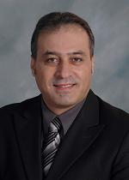

**Video Head Impulse Test (vHIT)**

Time: 2:00-4:00

Language: English

Short course

***Dr. Murad Al-Momani,*** *Ph.D., CCC-A, FAAA, Audiology Consultant, Chairperson of Audiology and Balance Unit, ORL-HNS Department, KAUH, Jeddah*

Dr. Murad Almomani does not have any relevant financial and non-financial information to disclose

**Able toing Outcomes:**

Attendees will able to to:

* Explain the basic principles of vHIT.
* Describe the clinical value of vHIT.
* Explain the technical matters when conducting vHIT.
* Interpret vHIT results.
* Perform hands-on.

**السبت 30 شوال 1444 20 مايو 2023**

~~**~~Cochlear Implantation Rehabilitation – A Deeper look into strategies~~**

~~Time: 4:00-6:00~~

~~Language: English~~

~~Short course~~

***~~Ms. Taaluf Albakree,~~*** *~~SLP, Senior Rehabilitation Therapist, Medel~~*

~~Ms. Taaluf Albakree does not have any relevant financial and non-financial information to disclose.~~

**~~Abstract:~~**

~~An ultimate goal of the different hearing modalities and rehabilitation services is to improve speech acquisition and language development of the hearing impaired. Moreover, rehabilitation plays a massive role in improving the quality of life of cochlear implantation recipients. This short course is intended to dig deeper into the different strategies used by speech therapists and families to enhance and improve able toing skills for the hearing-impaired children and adults. Focusing of strategies that are used for both pediatrics and adults with lots of examples an opportunity to share and exchange knowledge between participants.~~

**~~Able toing Outcomes:~~**

1. ~~Identify different habilitation and rehabilitation approaches to use with different cases of pediatrics and adults with hearing impairments.~~
2. ~~Explain the process and criteria of pre and post cochlear implantation rehabilitation including parent counseling, therapy goals and following up.~~
3. ~~Explain how to use and apply different techniques and strategies used in aural rehabilitation and auditory verbal therapy for recipients and their families for pediatrics and adults.~~
4. ~~Explain the key point of a successful rehabilitation journey with all age groups and will be able to use a variety of Auditory Verbal and language stimulation strategies.~~

**~~Targeted Audience:~~**

~~Speech Therapists and Aural rehabilitation specialists~~

**اعادة تأهيل زراعة القوقعة**

الأخصائية تآلف البكري – مسؤولة قسم التأهيل بشركة ميدال السعودية

مدة الورشة : ساعتين  
اللغة: العربية

يعتبر الهدف الأساسي من التدخل العلاجي بالحلول السمعية المختلفة للضعف السمعي هو تمكين الأشخاص ضعاف السمع من اكتساب وتطوير المهارات السمعية واللغوية لتكون مقاربة من مستوى الأقران. لذلك يلعب التأهيل دوراً هاماً في تحسين جودة الحياة بشكل عام عن طريق تدريب مستخدمي الحلول السمعية كزراعة القوقعة على استخدام المهارات السمعية بشكل أساسي لاكتساب اللغة والتواصل اللفظي. سوف نقدم لكم في هذه الورشة تدريبا وافياً عن الطرق المستخدمة في تأهيل زراعي القوقعة من الأطفال والبالغين والاستراتيجيات المساعدة للوصول للأهداف المرجوة. كما سنتناقش حول الكثير من المسائل الهامة حول تدريب الأهل وتمكينهم من الاهتمام بالجانب التأهيلي في رحلة زرعة القوقعة.

نتائج التعلم:

سيتعلم الحضور

* + معرفة أحدث الطرق المستخدمة لتأهيل زارعي القوقعة ومستخدمي الحلول السمعية والفروق بينهم.
  + معرفة وتطبيق آلية التأهيل ماقبل وبعد زراعة القوقعة ويتضمن ذلك التعاون مع الأهل وتطبيق الأهداف والمتابعة المستمرة.
  + معرفة وتطبيق الاستراتيجيات المختلفة المستخدمة في التأهيل السمعي اللفظي لتطبيق الأهداف العلاجية خلال الجلسات التدريبية.
* معرفة عوامل نجاح التأهيل وتفاصيل حول ذلك.

**السبت 30 شوال 1444 20 مايو 2023**

**Multidisciplinary Team Assessment of Behavioral and Developmental Disorders**

Time: 2:00-4:00

Language: English

Short course

***Sarah Alghunaim –*** *OT and certified Sensory Integration Therapist, Tayf Aziz Center, Riyadh*

***Halah Abuliyah –*** *Msc.CCC-SLP, BCaBA, QBA, Head of SLP Clinic, Tayf Aziz Center, Riyadh*

***Satha Oraini****, Psychologist, QASP-S, Tayf Aziz Center, Riyadh*

Ms. Sara Alghunaim does not have any relevant financial and non-financial information to disclose.

Mrs. Hala Abuliyah does not have any relevant financial and non-financial information to disclose.

Ms. Shatha Oraini does not have any relevant financial and non-financial information to disclose

**Abstract:**

The process of assessing children with behavioral and developmental disabilities is a going team effort. This course aims to shed the light on the importance of integration of multidisciplinary team (MDT) assessment approach to evaluate skill level, identify potential problems and areas of strength and weakness as related to interaction, cognition, communication skills, verbal skills, motor skills, and sensory integration. This approach is extremely valuable in guiding the intervention team to design an intervention plan and identify long-term and short-term treatment objectives included in the intervention plan.

**Able toing Outcomes:**

Attendees will able to to:

* Identify common psychometric assessments used to evaluate children with behavioral or developmental disabilities including (ADOS-2, Vineland-III, Conners-3, verbal, and nonverbal IQ tests)
* Identify the role of the occupational therapist in conducting sensory and motor assessments used to evaluate children with behavioral or developmental disabilities.
* Identify the role of speech-language pathology in MDT assessment of children with behavioral or developmental disabilities.
* Integrating results of psychology, OT and SLP assessments to support medical diagnosis of developmental and behavioral disorders and design intervention plan.

**السبت 30 شوال 1444 20 مايو 2023**

**اكتساب الأطفال ذوي التأخر اللغوي للضمائر المنفصلة والمتصلة باللغة العربية (لهجات) من خلال جلسات النطق واللغة**

الساعة: 4:00-6:00

اللغة: العربيه

دورة تدريبية

***د. جهاد أحمد المصري***

*ماجستير النطق واللغة دكتوراه التربية الخاصة، المدير الطبي لمركز الحنان المتميز للنطق واللغة*

Dr. Jihad Almasri does not have any relevant financial and non-financial information to disclose.

**أهداف الورشة:**   
1-التعريف بالضمائر باللغة العربية وأنواعها (العدد والجنس).  
2-التعريف بالضمائر باللغة العربية وأنواعها(المتكلم , المخاطب , الغائب) .  
3-كيفية صياغة الأهداف العلاجية الخاصة بالضمائر .  
4-كيفية اكساب الطفل للضمائربطرق سهلة وعملية .  
5-ترتيب الضمائر حسب حاجات الطفل اليومية .  
6-إشراك الأهل في عملية اكساب الطفل للضمائر بطرق وظيفية سهلة .  
7-أهم النصائح العملية التي تسرع اكتساب الطفل للضمائر .  
**الفئة المستهدفة بالبرنامج:**  
-أخصائي النطق واللغة .  
-مدربات التخاطب .  
-أخصائي تعديل السلوك .  
-معلمات الفصول ومساعدات المعلمات .  
-أخصائي التربية الخاصة .  
**نتائج التعلم :**

**سيتعلم الحضور**

* التعرف على الضمائر وانواعها باللغة العربية .
* التعرف على التدرج في اكساب الطفل للضمائر بأنواعها .
* صياغة الأهداف العلاجية الخاصة بالضمائر .
* اشراك الأهل في العملية العلاجية بطرق طبيعية وسهلة

**الاحد 1 ذو القعدة 1444 21 مايو 2023**