**الاحد 1 ذو القعدة 1444 21 مايو 2023**

**Factors Affecting Speech Fluency in Arabian Gulf (Khaleeji) Culture**

Time: 9:00 – 10:00

Language: English

Lecture

***Dr. Mona Indargiri,*** *PhD, SLP, Assistant professor - SLHS, Dar Al-Hekma University*

Dr. Mona Indarhiri does not have any relevant financial and non-financial information to disclose

Due to the lack of sufficient empirical data on childhood stuttering and  
parent-child interaction in Khaleeji (Arabian Gulf) culture, a questionnaire study was  
designed to examine Khaleeji parents' views, concerns and beliefs regarding the various  
factors that affect the child’s vulnerability to stuttering in a non-Western culture  
Therefore, parents’ opinion of treatment are crucial to consider since they play a pivotal role  
in their child's therapy (Hayhow, 2009). Parents are responsible for taking the child to  
and from clinics, practicing at home, and paying for services. Consequently, if parents  
were dissatisfied, unaware, or not involved in their child’s therapy, the treatment process  
would likely be affected. The knowledge and attitudes of the parents can have a  
significant impact on the success of the treatment.

**Learning outcomes:**

Attendees will be able to

* Explain how parental perception might contribute to appearance and development of  
  stuttering in Khaleeji culture.
* Describe the potential factors that might make children vulnerable to stuttering in  
  non -western culture.
* Explain if parents’ level of education have an impact on their perception of stuttering.
* Explain if parental gender differences have an impact on the effectiveness of therapy.

**الاحد 1 ذو القعدة 1444 21 مايو 2023**

**كيف نتعامل مع المشاعر والأفكار السلبية المرتبطة بالتأتأة لدى البالغين**

الساعة 10:00-12:00

اللغة: العربيه

محاضرة

***هدى عبدالكريم الصفدي***

*مركز جدة للنطق والسمع SLP Bsc*

Ms. HudaAllah Al Safadi has a financial and relationship with JISH as she is a JISH employee and receives a salary. Ms. HudaAllah has no non-financial information to disclose.

**نبذة:**

لوحظ أن لدى البالغين الذين لديهم تأتأة الكثير من المشاعر السلبية والأفكار التضخيمية وبالتالي التجنب والهروب من المواجهات الكلامية، فكان من الواجب العمل على هذا الجانب، وإيجاد الطرق الأمثل للتعامل معه، والذي يؤثر على حياة الفرد افجتماعية

**الأهداف:**

زيادة الوعي حول أهمية العمل على جانب الأفكار والمشاعر المرتبطة بالتأتأة، وإيجاد الطرق الأمثل للتعامل معها وإدارتها بناء ً على  
البحوث المأخوذة من كتاب أكثر من طلاقة، وكتاب الأفكار والمشاعر للسيطرة على الحالات المزاجية

* استخدام UTBAS
* استخدام طرق العلاج السلوكي المعرفي والعلاج بالتقبل والالتزامللمشاعر والأفكار والسلوك، وبالتالي تحليلها
* استخدام طريقة الرد على الأفكار السلبية
* استخدام الاعتراض على الأفكار السلبية
* تشجيع العميل على مزاحمة المواقف السلبية بأخرى إيجابية واقعية

**الاحد 1 ذو القعدة 1444 21 مايو 2023**

**Outcome of JISH Fluency Program and Comparing It to Similar Western Programs**

Time: 12:00 –1:00

Language: English

Panel

***Dr. Mona Indargiri,*** *PhD, SLP, Assistant professor - SLHS, Dar Al-Hekma* ***University***

***Ms. HudaAllah*** *Abdul Kareem Al Safadi, Bsc.,SLP, JISH*

***Dr. Asharaf Alsersy,*** *PHD, Clinical Psychologist, JISH*

***Ms Saraa Kamal,*** *Associate Certified Coach (ACC), International Coaching Federation (ICF)*

Dr. Mona Indargiri does not have any relevant financial and non-financial information to disclose

Dr. Ashraf Alsersy has a financial and relationship with JISH as she is a JISH employee and receives a salary. Dr. Ashraf Alsersy has no non-financial information to disclose.

Ms. Saraa Kamal does not have any relevant financial and non-financial information to disclose

Ms. HudaAllah Al Safadi has a financial and relationship with JISH as she is a JISH employee and receives a salary. Ms. HudaAllah has no non-financial information to disclose.

**Learning outcome:**

Attendees will be able to

* Describe the outcome of the program from Speech perspective.
* Describe the outcome of the program from psychology perspective.
* Describe the outcome of the program from the life coach perspective.
* Describe the challenges facing the clients in KSA vs. similar programs in western cultures.

**الاحد 1 ذو القعدة 1444 21 مايو 2023**

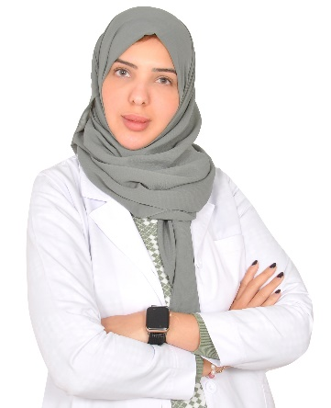

**اضطرابات التواصل الاجتماعي: التقييم واستراتيجيات التدخل**

الساعة: 9:00-11:00

اللغة: العربيه

دورة تدريبية

***روزان الخطيب***

*MA, CCC-SLP مدير برامج BCBA قسم النطق واللغة, مركز ستيبنج ستونز, الخبر*

Mrs. **Rozan** Alkhateeb does not have any relevant financial and non-financial information to disclose.

**ملخص:**

تهدف هذه الدورة القصيرة إلى مناقشة اضطرابات التواصل الاجتماعي. يتميز اضطراب التواصل الاجتماعي (SCD) بالصعوبات المستمرة في استخدام اللغة اللفظية وغير اللفظية للأغراض الاجتماعية. قد تكون الصعوبات الأساسية ظاهرة في أيا من: التفاعل الاجتماعي، الفهم الاجتماعي، التفاعل البراغماتي، والفهم والتحليل اللغوي . قد تتأثر سلوكيات

التواصل الاجتماعي مثل التواصل البصري، وتعبيرات الوجه، ولغة الجسد بالعوامل الاجتماعية والثقافية والفردية. سيواجه الأطفال الذين تم تشخيص إصابتهم اضطرابات التواصل الاجتماعي بتحديات في تفاعلاتهم اليومية بما في ذلك على سبيل المثال: المشاركة في البيئات الاجتماعية، وتطوير العلاقات الشخصية، وتحقيق النجاح الأكاديمي، وتأمين الوظيفة المناسبة. من المهم التأكيد على علامات وأعراض الاضطراب وأسبابه وانتشاره وتقنيات التشخيص والعلاج حيث لا يزال اضطراب التواصل الاجتماعي اضطرابًا لم يتم التعرف عليه بشكل واضح ومفصل في مجال التأهيل. يتوجب علينا كأخصائيين وأفراد من ضمن هذا المجتمع نشر الوعي فيما يتعلق بالممارسات القائمة على الأدلة العلمية أثناء التقييم والتدخل لتحسين نوعية الحياة للأطفال المصابين باضطراب التواصل الاجتماعي. كما أوضحت الدراسات الحالية أهمية استخدام التقييمات وأساليب العلاج المختلفة من قبل أخصائي أمراض النطق واللغة وأخصائيين تحليل السلوك التطبيقي لزيادة الفهم الاجتماعي والتفاعل الغير لفظي واللفظي للأطفال الذين تم تشخيصهم باضطرابات التواصل الاجتماعي.

**أهداف الدورة:**

عند الانتهاء من هذه الدورة القصيرة، سيكون الحاضرون قادرين على:

-شرح الأعراض المصاحبة لاضطراب التواصل الاجتماعي

- وصف الأسباب المحتملة للاضطراب

- شرح التقييمات المستخدمة لتشخيص الاضطراب

- شرح استراتيجيات التدخل المختلفة والفعالة

- وصف الأدوار المختلفة لفريق متعدد التخصصات في التقييم والتدخل مع الأطفال الذين تم تشخيصهم باضطراب التواصل الاجتماعي

- - مناقشة الاختلافات الثقافية واللغوية المرتبطة بالاضطراب

- مناقشة مجالات البحث المستقبلية لاضطراب التواصل الاجتماعي

**الاحد 1 ذو القعدة 1444 21 مايو 2023**

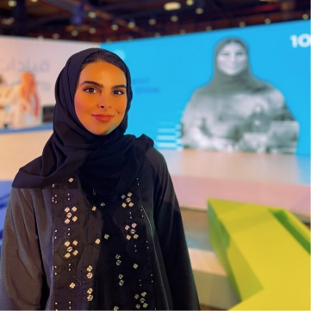

**Arabic Sensory Processing Measure –Preschool (SPM-P) And how do the speech therapists use them for their intervention plan?**

Time: **10:00 –1:00**

Language: English

Short course

***Dr. Shahad Mohammed AlKhalifah,*** *Senior OT, Head of Occupational Therapy, Autism Center of Excellence*

Dr. Shahad Alkhalifah does not have any relevant financial and non-financial information to disclose.

**Abstract:**

Autism spectrum disorder (ASD) is a pervasive developmental disorder associated with sensory processing disorders for 45 to 95% of people. Furthermore, the association between ASD and SPDs is such that sensory processing can discriminate between children with ASD and children with TD (Baranek, David, Poe, Stone, & Watson, 2006). Therefore, evaluating sensory processing at an early stage is as critical as assessing other developmental signs and symptoms (e.g., Zwaigenbaum et al., 2005), and early signs of sensory difficulties require addressing (Ben-Sasson, Carter, & Briggs-Gowan, 2009). The Sensory Processing Measure (SPM; Parham, Ecker, Miller Kuhaneck, Henry, & Glennon, 2013), and its infant version, the Sensory Processing Measure-Preschool (SPM-P; Ecker & Parham, 2010), are both available in a Home and a School version that are directly comparable. Indeed, the SPM comprises three forms: Home Form, Main Classroom Form, School Environments Form. The Home Form and the Main Classroom Form are the two main forms of the tool. Furthermore, the SPM-P and SPM not only assess each sensory system functioning, but also evaluated praxis performance. In doing so, it supports the assessment of what hinders a child’s occupational performance. The role of praxis in relation to SPDs is suggested as critical by Ayres (e.g., 1979), who suggested that it impacts occupational performance as much as sensory processing. Therefore, also evaluating praxis critically enables for planning of appropriate interventions (Glennon, Henry, & Herzberg, 2010). Yet, difficulties with praxis are often under-looked typical educational assessments, as they focus on task outcomes rather than the process followed up to the task completion. Using the SPM and the SPM-P thus addresses further limitations of other sensory processing assessments. Currently we have assessment tool available for Arabic speaking covering all ages. Due to the urgency in providing practitioners with appropriate tools, we assessed the psychometric properties of the Sensory Processing Measure- Preschool and Sensory Processing Measure -Home Form. Conclusion. The analyses suggest that the SPM-Home and the SPM-P-Home are adapting well.

**Learning Outcomes:**

Attendees will be able to

* Explain the research behind the development of these norm-referenced standardized assessment tools.
* Explain the principles of use of SPM-P and SPM to support the identification & treatment of SI/sensory processing difficulties, including praxis.
* Explain the administration and scoring of SPM-P and SPM.
* Explain the question: “Are sensory issues driving the behaviors?”
* Explain the use of SPM-P and SPM in multiple environments, encouraging collaboration among parents, schools, preschools, daycares, and clinics.
* Explain how the assessment could be used with the multidisciplinary team.

**الاحد 1 ذو القعدة 1444 21 مايو 2023**

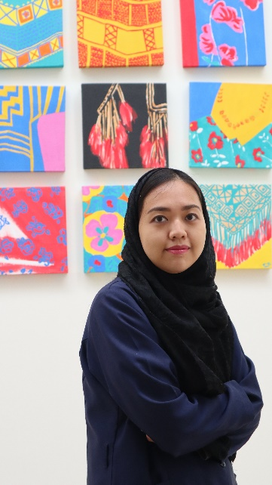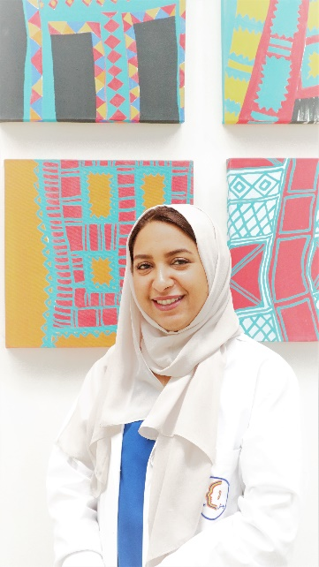

**My child is driving me crazy? - Using behavioral strategies to prevent and reduce problem behaviors**

Time: 9:00 –11:00

Language: English

Short course

***Sanaa Ibrahim,*** *MA, Applied Behavior Analysis and Autism, BCBA, Jeddah Institute for Speech and Hearing and Medical Rehabilitation*

***Enas Abdulla,*** *M.Sc., Applied Psychology, BCBA, Jeddah Institute for Speech and Hearing and Medical Rehabilitation*

Ms. Sanaa Ibrahim has a financial and relationship with JISH as she is a JISH employee and receives a salary. Ms. Sanaa Ibrahim has no non-financial information to disclose.

Ms. Enas Abdulla has a financial and relationship with JISH as she is a JISH employee and receives a salary. Ms. Enas Abdulla has no non-financial information to disclose.

**Abstract:**

A variety of interventions are available to support social-communication skills for children with  
communication disorder to enhance their communication at home, school, and in the community.  
These interventions include discrete trial instruction (Lovaas, 1978), verbal behaviors that  
includes echoes, mands, tacts, and intraverbals (Sundberg & Michael, 2001), pivotal response

**Learning outcomes:**

Attendees will be able to

* Analyze behavior based on antecedent and consequence
* Identify reasons why the child may engage in problem behaviors
* Describe strategies to deal with problem behaviors when they occur
* Demonstrate strategies on how to intervene with severe problem behavior
* Describe strategies to prevent problem behaviors from happening and reduce them in  
  future.

**الاحد 1 ذو القعدة 1444 21 مايو 2023**

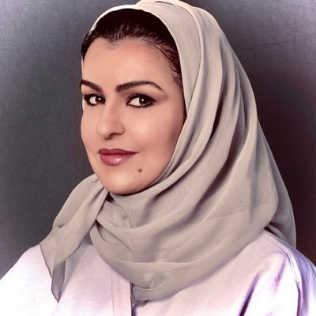**Interprofessional Collaboration and Practice within ASD Population: Autism Center of Excellence (ACE) Experience**

Time: 11:00 –12:00

Language: English

Lecture

***Ms. Malak AlRamady,*** *M.sc. CCC-SLP, Senior Specialist, Autism Center of Excellence*

Ms. Malak AlRamady does not have any relevant financial and non-financial information to disclose.

**Abstract:**

This One-hour lecture will address interprofessional collaboration and practice between SLPs and other disciplines (ABAs, OTs) when assessing and implementing intervention plans for those with autism spectrum disorders (AAC). Focusing on a local team practice (Autism Center of Excellence) team where collaboration improved outcomes for their clients with ASD across different ages and severities. The speaker will address terminology and language frameworks used by each field, highlight the perspective of each discipline, and share practical strategies for facilitating collaboration and significant outcomes.

**Learning Outcomes:**

Attendees will be able to

* Identify similarities and differences in training, scope of practice, and competencies of SLPs, ABA specialists and OTs.
* Identify the 3 key principles about IPE/IPP.
* Describe differences in terminology and language frameworks between the fields of speech-language pathology and other disciplines
* Define practical strategies for effective collaboration between SLPs and other professionals when planning intervention for those with autism spectrum disorder (ASD).
* Describe an understanding on Interprofessional Practice (IPP) in action within a local team: Autism Center of Excellence (ACE) experience.

**الاحد 1 ذو القعدة 1444 21 مايو 2023**

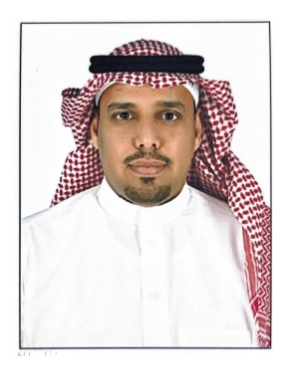

**Biological interventions for post-stroke aphasia: The current evidence and future directions**

Time: 12:00 –1:00

Language: English

Lecture

***Dr. Mohammed Fala AlHarbi****, PhD, CCC-SLP, Assistant Professor and Department Chair of SLP-A Program, Taibah University.*

Dr. Mohammed AlHarbi does not have any relevant financial and non-financial information to disclose.

**Abstract:**

Aphasia is an acquired language disorder that affects about 30% of stroke survivors. Aphasia is known to have a negative impact on quality of life of people with aphasia and associated with economic burdens due long-term rehabilitation needs.

Traditional aphasia rehabilitation can be effective even in chronic cases; however, the rehabilitation takes a long time and full restoration of language is rarely achieved. Therefore, researchers have been exploring new techniques that can speed up language recovery and make traditional aphasia rehabilitation more efficient. Among the new techniques, the biological based techniques which include brain stimulation such as repetitive transcranial magnetic stimulation (rTMS) and neuromodulation technology such as transcranial direct stimulation (tDCS). Recently, these techniques have shown promising results in boosting language functions in post-stroke aphasia. However, despite the great advantages that these techniques offer to aphasia rehabilitation, it is not yet approved for clinical use due to several methodological issues.

In this presentation, the current evidence for using biological intervention for post-stroke aphasia will be discussed. Specifically, the presentation will provide an introduction for biological intervention in aphasia including the definition and theoretical basis for using brain stimulation and neuromodulation. Then, the evidence of using both techniques ( rTMS and tDCS) in improving language functions in post-stroke aphasia will be reviewed. Methodological issues and future directions for using both techniques will also be discussed.

**Learning Outcomes**

Attendees will be able to

* Define repetitive transcranial magnetic stimulation (rTMS) and transcranial direct current stimulation (tDCS) and its basic mechanisms.
* List the factors that can influence rTMS and tDCS effect.
* Explain the rationale for using rTMS and tDCS for post-stroke aphasia.
* Describe different rTMS and tDCS montages used with post-stroke aphasia.
* Describe the current evidence and the future directions for using tDCS in post-stroke aphasia.

**الاحد 1 ذو القعدة 1444 21 مايو 2023**

**ورشة تطبيق وتصحيح وتفسير مقياس ستانفورد- بينية للذكاء (الصورة الخامسة)**

الساعة: **9:00 – 1:00**

اللغة: العربيه

ورشة عمل

***د/أشرف محمود السرسى***

*أخصائي نفسى علاجى*

Dr. Ashraf Alsersy has a financial and relationship with JISH as he is a JISH employee and receives a salary. Dr. Ashraf Alsersy has no non-financial information to disclose.

الملخص

ستانفورد بينيه الصورة الخامسة هو مقياس يطبق فرديا لقياس الذكاء والقدرات المعرفية وهو ملائم للمفحوصين بداية من عمر سنتين حتى 85 عاما فأكثر، ويتم تطبيق هذا الإختبار بناء على الخلفية الثقافية للبيئة العربية حيث تم تقنينةعلى بعض الدول العربية لذلك فقد أصبح ذو مصداقية عالية وهو يوفر نسبة ذكاء كلية ونسبة ذكاء لفظية وغير لفظية، ويقيس خمسة عوامل معرفية هى كالتالى :

الاستدلال التحليلي وهوالقدرة التحليلية التي يمتلكها الفرد وفق المنطق البديهي قبل أن يحصل على أي قدر من التعلم النظامي اللاحق فهو صمم ليكون متحرر من أي تعلق بالمعلومات المشتقة من التعلم المدرسي أو الخبرة السابقة وهو يعتمد على فهم العلاقات الشكلية أو اللفظية غير المستمدة من الحضارة.

المعلومات وهى القدرة الناتجة عن التعلم النظامي أو الغير نظامي ويعتمد على حسن استخدام المعلومات التي توفرت للمفحوص. الاستدلال الكميوهو القدرة على إدراك وفهم الكميات والاعداد وتقييم الخصائص الهندسية من مسافات وأبعاد. المعالجة البصرية المكانية وهى التنظيم العقلي للمواد العيانية وتنظيمها في صورة أنماط وفق نماذج مقدمة. الذاكرة العاملة العملية المعرفية التي تقف خلف الاختزان المؤقت للمعلومات واختزانها وتحويلها وإعادة تصنيفها في الذاكرة بعيدة المدى

الأهداف التعليمية للبرنامج:

* التدريب على مهارة التطبيق العملي وتفسير الدرجة المعيارية المركبة الكلية، والدرجات المعيارية المركبة الخاصة بالمجالات المكونة للمقياس.
* التدريب النظري والعملي على كيفية استخرج نقاط القوة والضعف
* التدريب على التطبيق العملي للمقياس وذلك عن طريق التدريب المتبادل بين الطلبة، والتدريب العملي على إحدى الحالات المتطوعة

الفئة المستهدفة :

* الأخصائيون النفسيون بوجه عام
* الأخصائيون النفسيون الإكلينيكيون
* العاملون في مجال القياس النفسي
* العاملون في مجال التربية الخاصة
* طلبة علم النفس

**الاحد 1 ذو القعدة 1444 21 مايو 2023**

**Introduction in Augmentative and Alterative Communication (AAC)**

Time:9:00 –11:00

Language: English

Short course

***Ms. Ayah Othman Sindi,***

*M.Sc., CCC SLP MSc in Audiology, Lecturer, KAU-SLP-A Medical*

*Rehabilitation Sciences, Jeddah, Saudi Arabia*

Ms. Aya Sindi does not have any relevant financial and non-financial information to disclose.   
 **Abstract:**This short course is designed for any allied healthcare professional new to the field of AAC. It will provide information on the foundations of AAC including its definition, the types and classification system, and the different types of persons with communication disorders who might benefit from using AAC. Also, the course will present common misconceptions about using AAC and will present the latest scientific evidence to refute these misconceptions. Furthermore, the course will introduce the general goal of AAC, the concept of using a Multi-Modal Approach, and the components of a Robust AAC System. Afterwards, the course will present information on one common type of a Robust AAC System, known as Core Word Language System, an Evidence- Based Practice (EBP) language system. Finally, the course will explain the first step in all AAC intervention (i.e., Aided Language Input), provide scientific evidence to support this intervention method and its effectiveness, and provide tips and strategies on its implementation.

**Learning Outcomes:**

Attendees will be able to:

* Describe what AAC is, the different types of AAC, and the persons who benefit from using AAC.
* List the common misconceptions about using AAC and provide the scientific rebuttals.
* Describe the general goal of AAC and how to use a Multi-Modal Approach to support achieving the goal.
* List the components of a Robust AAC System.  
  Describe the Core Word Language System as an example of one Robust AAC System.
* List at least 3 different strategies used during the first step of AAC intervention (i.e., Aided Language Input).

**الاحد 1 ذو القعدة 1444 21 مايو 2023**

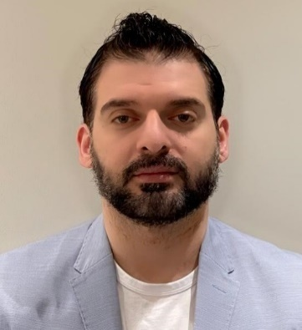**Acoustic Reflex**

Time:**11:00 –1:00**

Language: English

Short course

***Dr. Mohamed N. Garrada,*** *Audiovestibular Medicine Specialist, KAU, Jeddah*

Dr. Mohammed Garrada does not have any relevant financial and non-financial information to disclose.

**Abstract:**

The acoustic reflex, also known as the stapedius reflex, refers to an involuntary muscle contraction of the stapedius muscle in response to a high-intensity sound stimulus. Due to ease of administration and information yielded, the acoustic reflex is considered one of the most powerful differential diagnostic audiological procedures.

The acoustic reflex and the tympanogram are commonly used to assess middle ear function and are considered best practice. Each test yields invaluable information based on the delivery of acoustic energy (sound) to the ear canal.

The presence of reflexes within normal intensity limits is consistent with middle ear and brainstem function and suggests that auditory sensitivity is not significantly impaired. An elevated or absent acoustic reflex threshold is consistent with a middle ear disorder, hearing loss in the stimulated ear, and/or interruption of neural innervation of the stapedius muscle.

**Learning Outcomes**

Attendees will be able to

* Explain the normal structure of stapedius reflex.
* Define the acoustic reflex.
* Recognise the clinical indications of the test.
* Identify the diagnostic applications of ART.
* Perform the stapedius reflex measurements.

**الاحد 1 ذو القعدة 1444 21 مايو 2023**

**Feeding and Sensory difficulties**

Time:10:00 –11:00

Language: English

panel

***Dr. Shahad Mohammed AlKhalifah,*** *Senior OT, Head of Occupational Therapy, Autism Center of Excellence*

***Mr. Ahmad Eid****, SLP consultant, BCBA*

***Dr. Sameera Deheithem,*** *Clinical doctorate, CCC-SLP, KFSHRC*

Dr. Shahad AlKhalifah does not have any relevant financial and non-financial information to disclose.

Mr. Ahmed Eid does not have any relevant financial and non-financial information to disclose.

Dr. Sameera Deheithem does not have any relevant financial and non-financial information to disclose.

**Abstract:**

Children with ASD and related disorders show different kind of feeding problems related to many reasons. One of the significant causes of these feeding difficulties is related directly to sensory issues. Research tells us that multidisciplinary team management is effective in management of feeding difficulties. The core team members are OT, SLP and behavior analyst. This panel will discuss the role of each discipline in management of sensory issues in feeding.

**Learning Outcomes:**

Attendees will be able to

* List the sensory issue of feeding.
* Describe the sensory impact on feeding skills from behavioral perspective.
* List the possible management of feeding sensory issue from behavioral perspective.
* Describe the multidisciplinary interventions of sensory issues.
* Describe The correlation between sensory difficulties and feeding issues.
* Describe Picky eater’s vs Problem feeders.
* Explain what is feeding therapy? And when to start?

**الاحد 1 ذو القعدة 1444 21 مايو 2023**

**Applying morphological awareness to Arabic speech-language therapy sessions**

Time:2:00 –3:00

Language: English

Lecture

***Dr. Nada Faquih,*** *PhD, SLP, Vice Dean of the College of Medical Rehabilitation Sciences-Females Sector, KAU, Jeddah*

Dr. Nada Faquih does not have any relevant financial and non-financial information to disclose.

**Abstract:**   
Morphological awareness (MA) is a current and recommended technique to  
apply with children with Developmental Language Disorders (DLD). Given that Arabic is  
a highly inflectional language, which is specifically challenging for the DLD  
population, it is predicted that applying morphological awareness will be beneficial.  
The talk will present about literature and studies written about morphological  
awareness and suggested MA tasks for Arabic language speakers..

**Learning Outcomes:**

Attendees will be able to

* Define morphological awareness
* Describe the usage of morphological awareness in speech-language therapy.
* Describe applying morphological awareness for Arabic language speakers.

**الاحد 1 ذو القعدة 1444 21 مايو 2023**

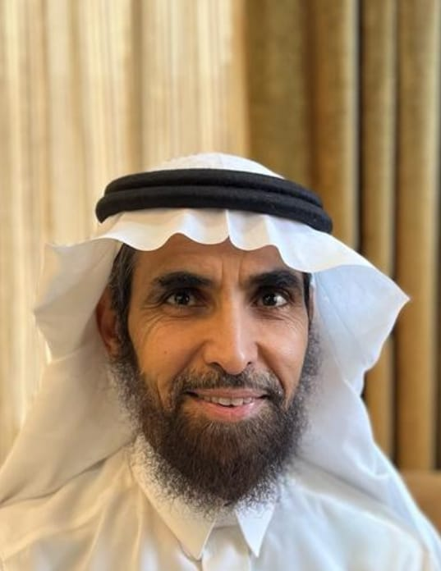**Treatment of Swallowing Disorders in Adults**

Time:**3:00 –4:00**

Language: English

workshop

***Abdulrahman Ibrahim Al-Akeel,*** *PhD, SLP, Consultant Pathologist in Swallowing and Communication Disorders*

Dr. Abdulrahman Al-Akeel does not have any relevant financial and non-financial information to disclose.

**Abstract:**

Impairment in swallowing function can be caused by several etiologies such as Cerebrovascular Accidents (CVA), Traumatic Brain Injuries (TBA), tumours or traumas. Speech-language pathologist (SLPs) are the healthcare professionals who provide assessment and therapy for impairments in swallowing function. The first step in swallowing assessment is a clinical swallowing screening that is done at bedside for inpatients or at the clinic for outpatients. The result of this clinical screening will indicate whether an instrumental swallowing assessment is needed or not. The most widely used instrumental swallowing assessment procedures are Video Fluoroscopy Swallow Study (VFSS) and Fibreoptic Endoscopic Examination of Swallowing (FEES). The availability of facilities and the client’s swallowing status will help an SLP to decide whether to use VFSS or FEES or both. Results of instrumental swallowing assessment helps an SLP in identifying impairments in swallowing functions and deciding on the most relevant swallowing treatment techniques. Swallowing treatment may include diet modifications, compensatory techniques, or direct swallowing exercises.

**Learning Outcomes:**

Attendees will be able to

* Describe the impairment in swallowing function based on data from video fluoroscopy swallow studies (VFSS).
* Describe the impairment in swallowing function based on data from Fibreoptic Endoscopic Examination of Swallowing (FEES).
* Identify the most relevant swallowing therapy technique(s) based on the case scenarios provided during the workshop.
* Select the most relevant diet to the client based on the case scenarios provided during the workshop.
* Identify contraindications for using therapy particular strategies with clients suffering from different impairment in swallowing function.

**الاحد 1 ذو القعدة 1444 21 مايو 2023**

**Application of ABA Principles in Speech and Language Intervention**

Time:2:00 –6:00

Language: English

Short course

***Halah Abuliyah,*** *Msc.CCC-SLP, BCaBA, QBA, Head of SLP Clinic, Tayf Aziz Center, Riyad*

Mrs. Halah Abuliyah does not have any relevant financial and non-financial information to disclose.

**Abstract:**

The science of ABA combined with a solid theoretical and clinical expertise of a skilled SLP maximizes the outcomes of the intervention plan. This workshop intends to discuss the effect of incorporating evidence-based principles and approaches of ABA in the SLP intervention for children with communication disorders to improve speech, language and overall communication skills. Examples

of ABA-based approaches are Incidental Teaching and Naturalistic Environmental Teaching, which results in rapid acquisition and generalization of communicative behaviors in speech therapy sessions. In addition, the workshop will highlight the Verbal Behavior Approach, with a focus on data collection, functional use of language and promoting generalization.

**Learning Outcomes:**

Attendees will be able to

* Identify ABA Intervention Approaches that correspond to SLP intervention.
* List short-term and long-term objectives that align with the 7 dimensions of ABA
* Identify ABA data collection techniques useful in SLP sessions.
* Integrate Verbal Behavior Approach in SLP intervention.
* Describe how to work collaboratively with ABA team members to achieve generalization of skills.

**الاحد 1 ذو القعدة 1444 21 مايو 2023**

**Aphasia Rehabilitation**

Time:2:00 –6:00

Language: English and Arabic

workshop

***Ms. Hanan Alzahrani,*** *Msc, SLP, Senior SLP, KSU Medical City, Riyadh*

***Ms. Ghaida Alabdulgader,*** *Msc, SLP, Senior SLP, KSU Medical City, Riyadh*

Ms. Hanan AlZahrani does not have any relevant financial and non-financial information to disclose.

Ms. Ghaida Alabdulgader does not have any relevant financial and non-financial information to disclose

**Abstract:**   
According to the Saudi Stroke Society, the worldwide stroke incidence is around 25 million. Because a large proportion of strokes affect the left hemisphere and likely occur somewhere along the left middle cerebral artery, which supplies blood to the language areas of the brain, many of these stroke survivors suffer from aphasia. Speech language pathologists deliver evidence-based therapy approaches to improve and/or maintain their communication skills. Aphasia rehabilitation is crucial at early stages; however lack of Arabic resources is a huge challenge for specialists in the field. The “Language Rehabilitation for Individuals with Aphasia Book” was created by well experienced/ senior speech language pathologists for Arabic-speaking patients. The aim of the workshop is to provide background knowledge on dealing with aphasia as well as written and verbal exercises from the book. The language rehabilitation book includes evidence-based therapy that utilizes a variety of tasks in many levels suitable for people with aphasia.

The workshop will be divided into two sections: theoretical and practical. The theoretical section will summarize the brain recovery function following neuroplasticity principles, evidence-based practice, and different therapeutic approaches for individuals with aphasia with different severity. The practical part will involve hands-on training using the book with audio and video recording examples.

Aphasia rehabilitation workshop is appropriate for clinicians dealing with individuals with aphasia from post-onset and over time for chronically affected patients.

**Learning Outcomes:**

Attendees will be able to

* Demonstrate an understanding of different therapy approaches.
* Describe the differences between impairment-based goals and functional based goals.
* Describe appropriate goals for persons with aphasia (PWA).
* Explain various activities in therapy for PWA and analyze responses.
* Assess data to continually evaluate the effectiveness of the therapy program.
* Describe effective and appropriate counselling techniques to PWA and caregivers

**الاحد 1 ذو القعدة 1444 21 مايو 2023**

**التأهيل اللغوي للأطفال المصابين بالتوحد واعاقات اخرى من خلال استخدام مفاهيم تحليل بي إف سكينرز للسلوك اللفظي BF Skinners**

الساعة: 2:00-6:00

اللغة: العربية

ورشة عمل

***شيرين محمد بصفر***

*محلل سلوكي معتمد BCBA مدير البرامج، كاربون كلينك في دبي*

Ms. Cherine Basfar does not have any relevant financial relationship with JISH but has a non-financial relationship with JISH as she sometimes volunteers to work at JISH.

**الملخص**

سيتم خلال العرض التقديمي التركيز على أهمية دمج تحليل بي. إف سكينرز (1957) للسلوك اللفظي في إعداد برامج التأهيل اللغوي للأطفال المصابين بالتوحد والإعاقات الأخرى. بالإضافة إلى ذلك، سيتم عرض وتقديم تقييمين يعتمدان على تحليل سكينرز للسلوك اللفظي بشكل موجز (على سبيل المثال ، تقييم معالم السلوك اللفظي وبرنامج تحديد المستوى (VB-MAPP) Sundberg, 2008 ، وتقيم الأسس الحياتية Essential for Living، McGreevy & Fry, 2012). كما سيتم عرض بعض ملفات المتعلمين في مركز كاربون كلينك من أجل المساعدة في مناقشة الأهداف والبرامج المناسبة، وسوف تُدعَّم المناقشات عن طريق العديد من الرسوم التوضيحية والفيديوهات التعليمية الموثقة.

**الأهداف التعلمية:**

* موجز لتفسير سكينرز للسلوك اللغوي.
* وصف كيفية إمكانية تعليم مهارة الطلب بناءً على تحليل سكينرز للسلوك اللفظي.
* وصف كيفية التأهيل اللغوي خلال تعليم البيئة الطبيعية (NET)
* تحليل كيفية إمكانية تطوير عملية التحفيز الانعكاسي المشروطة (CMO-R) في الإعدادات التعليمية ووصف إجراءات التأهيل الفعالة المستخدمة لإلغاء عملية CMO-R.
* وصف التحضيرات عند إجراء تعليمات التجربة المنفصلة (DTI).
* تقديم نظرة عامة لتقييمين يعتمدان على تحليل سكينرز (1957) للسلوك اللفظي (أي، تقييم معالم السلوك اللفظي وبرنامج تحديد المستوى (VB-MAPP) وتقيم الأسس الحياتية Essential for Living).
* تحديد المرحلة المناسبة لاستخدام تقييم معالم السلوك اللفظي وبرنامج تحديد المستوى (VB-MAPP) وتقيم الأسس الحياتية Essential for Living.

**الاحد 1 ذو القعدة 1444 21 مايو 2023**

**Moving Toward an Arabic Test Battery for Speech Audiometry**

Time:2:00 –3:00

Language: English

Short course

***Dr. Hanin Rayes,*** *AU.D., PH.D. Assistant Professor, KAU-SLP-A Medical*

*Rehabilitation Sciences, Jeddah, Saudi Arabia*

Dr. Hanin Rayes does not have any relevant financial and non-financial information to disclose.

**Abstract:**

**Background and Aim:** Speech audiometry is essential when assessing children with hearing loss and measuring the  
outcomes of their hearing devices. The aim of this project is to evaluate audiologists' practices  
during pediatric speech assessments and to gain a better understanding of obstacles that may  
interfere with the delivery of speech testing.  
A questionnaire adapted but modified from Parmar et. al. (2022), was distributed to audiologists in Saudi Arabia. Thirty-four audiologists responded to the questionnaire. Ninety-one percent of the participants believed that speech tests are beneficial for pediatric assessment, and they reported a significant lack of speech materials. Furthermore, 82% of the participants stated that they would perform speech testing if speech materials were accessible. Based on the feedback, a platform that makes appropriate speech materials accessible to audiologists was developed in a form of an application that is now available in the Apple Store and Google Play for smartphones, iPads, and  
tablets. Currently, the application offers the Arabic version of the CAPT (Rayes et.al., 2019) and the Arabic version of the DiaPix. The application allows the developer to add additional speech materials easily and efficiently. Moreover, with the help of parents, audiologists can assess the speech perception of the children at home, a feature of the application that can be helpful with  
‘uncooperative children’; an obstacle that may interfere with conducting pediatric speech  
assessment at the clinic as audiologists reported in the questionnaire.  
The application is evidently needed and would be used by at least 80% of the audiologists in  
routine pediatric evaluations.

**Learning Outcomes:**

Attendees will be able to

* Describe the value of speech audiometry when assessing children with hearing loss and measuring the outcomes of their hearing devices.
* Describe obstacles that may interfere with conducting pediatric speech assessment.
* Summarize an application that provides different speech materials easily and efficiently.

**الاحد 1 ذو القعدة 1444 21 مايو 2023**

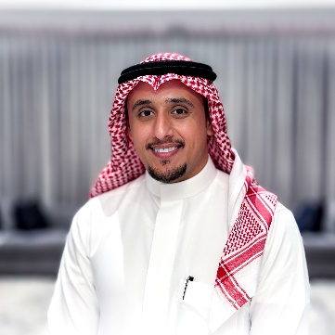**The Impact of Various Frequency-Lowering Algorithms on Speech Intelligibility and Quality**

Time:3:00 –4:00

Language: English

Short course

***Mr. Anas Mohammed AlShaya,*** *MSc. in Audiology, Audiologist and Teaching Assistant, KAU-SLP-A Medical Rehabilitation Sciences, Jeddah, Saudi Arabia*

***Ms. Ala’a Sindy****, MSc in Audiology, Lecturer, KAU-SLP-A Medical*

*Rehabilitation Sciences, Jeddah, Saudi Arabia*

Mr. Anas Alshaya does not have any relevant financial and non-financial information to disclose.

Ms. Ala’a Sindi does not have any relevant financial and non-financial information to disclose.

**Abstract:**Since hearing aids have limited bandwidth, frequency-lowering algorithms were made to increase bandwidth by resampling high-frequency speech sounds into lower, audible frequencies. The goal of these algorithms is to widen the range of frequencies that can be heard. while minimizing the potential negative effects of distortion and decreasing our ability to differentiate between frequency variations. There are numerous examples of frequency-lowering algorithms, but they all serve the same function. Thus, if we apply various different algorithms for lowering the received frequency so that it can be audible, we want to know what happens to speech intelligibility and quality when frequency lowering is used.

**Learning Outcomes:**

Attendees will be able to

* Describe how hearing aid bandwidth restrictions necessitate frequency-lowering algorithms.
* Describe the impact of frequency-lowering on speech intelligibility.
* Describe the impact of frequency-lowering on speech quality.

إياد: هذه محاضرة جديدة فضلا اضافتها للبروشور

**الاحد 1 ذو القعدة 1444 21 مايو 2023**

**Speaker Emergen Protocol**

Time:4:00 –4:30

Language: English

Lecture

***Dr. Sara Silsilah,*** Senior Consultant, PhD, BCBA-D, CABAS Master Teacher

**Abstract:**We studied the effects of a Speaker Immersion Protocol on the number of vocal, verbal operants emitted in non-instructional settings using a delayed multiple probe across participants design, with two preschoolers with developmental delays. The dependent variables were the numbers of target mands emitted in the presence of contrived establishing operations and the numbers of vocal, verbal operants emitted during 10 min probe sessions across 3 different non-instructional settings. The intervention was the Speaker Immersion Protocol (SIP). The protocol involved the use of contrived establishing operations throughout the day during instructional and non-instructional settings to induce vocal verbal behavior. Each session of the SIP involved 60 contrived establishing operations. Results for Participant 1 and 2 showed significant increases in target mand responses to contrived establishing operations. Participant 1 and 2 also demonstrated increases in vocal emissions across non-instructional settings during vocal, verbal operant probes. These findings suggest that the speaker immersion protocol increased the number of target mand emissions in contrived and non-instructional settings for both participants.

**Learning outcomes:**

Attendees will be able to

* Describe the Speaker Immersion Protocol (SIP).
* Identify the effects of using SIP.
* Describe probes for assessing language in non-instructional settings.
* Use contrived establishing operations to promote language development.